Meeting: Executive, October 2023 | Author: Darren Bird, Alex Clark
Subject: Customer complaints forum

Background
As part of our commitment to the Housing Ombudsman complaint code and improving our complaint handling, we advised the Board in July 22 that we would be creating a new Customer complaints forum. This paper gives an update on the progress of this group and the results on their recent findings.

Purpose of the group
The remit of the forum is to be a critical friend, reviewing completed complaints to ensure that we follow the expectations of the Housing ombudsman complaint code, they are dealt with in a sympathetic manner with fair resolutions.
The forum consists of 6 customers. The group had grown from 4 to 7 members but one of our original members has withdrawn due to personal circumstances.
Our new members were provided with 2 test cases to enable them to score and comment on the handling of these cases. We established that they were clear about their remit and provided appropriate scores and feedback. During the October meeting all 6 forum members chose 5 new cases to review.

Scope
They meet every quarter.

They are provided with ten anonymised complaint cases that have gone through
our complaints process and now closed. They receive the headline complaint reason
and the complaint number.

The group will agree on five (of the ten) and receive fuller details, including all the
notes, correspondence, outcomes, and learnings. They are then required to
individually score and assess the following areas of our handling of those
complaints:

- Quality of the notes
- Correct correspondence
- Dealt with inside timescales
- Chronology of events
- The outcome
- Fairness in the handling of the complaint
- Putting things right

They also provide a written summary of the scores to give insight.

Results
The forum has reviewed and scored five complaints and gave their feedback – the table below shows the average score of the group in each area.

Area of review | Score (out of 5)
Quality of notes | 3.0
Correct correspondence | 3.4
Timescales | 3.5
Chronology of events | 3.4
The Outcome | 3.4
Fairness in the handling of complaint | 3.6
Putting things right | 3.5

Positive feedback
Well executed, excellent example of how to deal with a case, positive learning outcome, clear and concise notes.

Development feedback
Unclear, confusing, staff require training, poor customer service.
Summary and next steps
The results continue to provide valuable feedback.
A log of agreed actions has been created and is reviewed at each quarterly forum meeting, the group is asked for their feedback and actions taken are feedback to them.
As a direct result of the forums feedback we agreed that new staff would not be allocated a complaint case for the first two months of employment to allow them time to settle in and receive appropriate training.
Our top performing complaint scored 114 points (out of an available 140), the poorest complaint scoring 59 points.
The feedback has been shared with the case managers and their managers to recognise where we have managed and dealt with it well, whilst ensuring additional support and training is put in place for the members of staff where we did not score so well.
Our marketing and comms team will be regularly providing updates to our customers and are currently creating an in-depth plan for ongoing communications.
At each future meeting a senior team member will attend the forum to provide an insight into different areas of the business. This will provide the forum with a clear understanding of Selwood’s processes and approach to customers.
Options and recommendations
Note this report and agree that quarterly updates will come to the Exec team.
Appendix
Appendix A – Complaints reviewed and how the Customer complaints forum operates.

Complaints reviewed
Complaint number | Nature of complaint
17279 | Garden maintenance
17301 | Tenancy Termination
17309 | EOD – Direct Debit Error
17371 | EOD – Parking Issues
17412 | EOD – Kitchen Installation

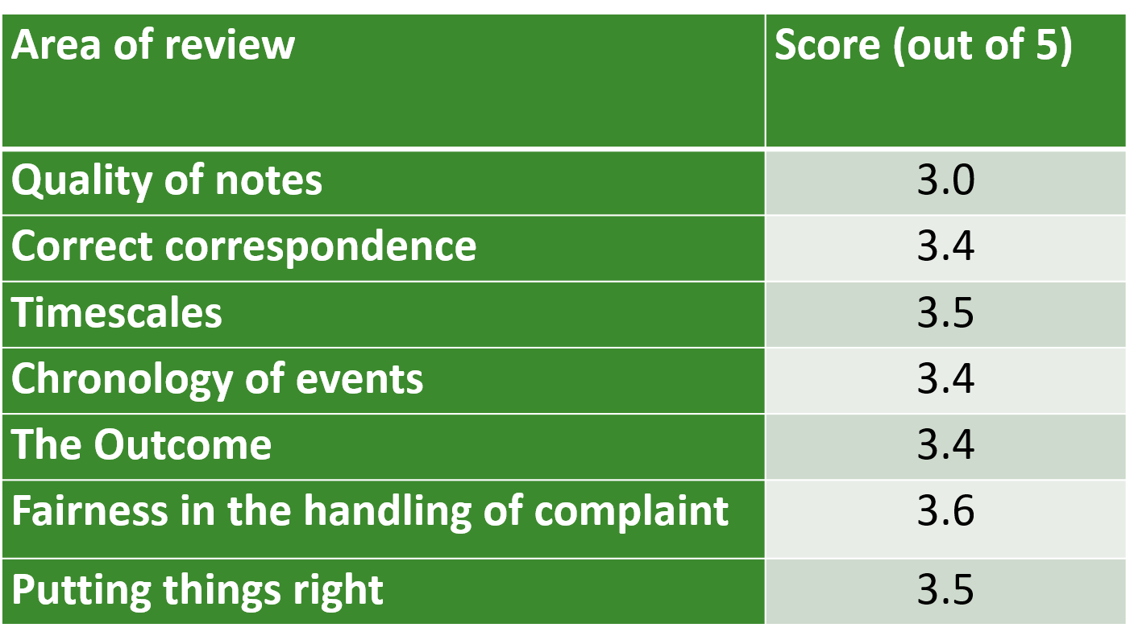
How the Customer complaints forum operates
They meet every quarter.
They are provided with ten anonymised complaint cases that have gone through our complaints process and now closed. They receive the headline complaint reason and the complaint number.

The group will agree on five (of the ten) and receive fuller details, including all the notes, correspondence, outcomes, and learnings.

They will assess and feedback on these elements:

Quality of notes.

- are they clear/could they be misinterpreted.
- contain enough detail
- would you have expected more information
- notes should be factual not an opinion

Correct correspondence sent

- acknowledgement
- response letter
- closure letter
- did we promote the Housing Ombudsman service

Correspondence sent within agreed timescales

- acknowledgement sent within 5 working days
- response letter sent within 10 working days
- extra time agreed is required

Could the complaint be followed from start to finish

- Chronological order

Complaint outcome

- Does the outcome look and feel right
- Would you have done anything differently

Was the complaint dealt with Fairly

- Have we been impartial
- Did we compromise and show flexibility
- Was the complaint dealt with in a way the customer could understand
- Was the language clear and concise

Did we Put Things Right

- Have all points raised been addressed
- Was the customer compensated correctly

Each of these elements are scored by the forum member, based on this scoring matrix.

Score | Definition – could include these elements
1 | Timescales not maintained, letters not sent, limited notes, no learning outcome recorded.
2 | Most parts could have been improved on, lacking information or not clear with our approach.
3 | Some information missing, the case has been fairly dealt with and things have been put right.
4 | Most elements were adhered to but there was room for improvement in some parts.
5 | All letters and timescales have been adhered to, clear and detailed notes, case has been dealt with fairly and things have been put right, we have apologised.

Each forum member will sum up each complaint with a summary of their score(s)

Complaint outcome

- Does the outcome look and feel right
- Would you have done anything differently

Was the complaint dealt with Fairly

- Have we been impartial
- Did we compromise and show flexibility
- Was the complaint dealt with in a way the customer could understand
- Was the language clear and concise

Did we Put Things Right

- Have all points raised been addressed
- Was the customer compensated correctly

Each of these elements are scored by the forum member, based on this scoring matrix.

Score | Definition – could include these elements
1 | Timescales not maintained, letters not sent, limited notes, no learning outcome recorded.
2 | Most parts could have been improved on, lacking information or not clear with our approach.
3 | Some information missing, the case has been fairly dealt with and things have been put right.
4 | Most elements were adhered to but there was room for improvement in some parts.
5 | All letters and timescales have been adhered to, clear and detailed notes, case has been dealt with fairly and things have been put right, we have apologised.

Each forum member will sum up each complaint with a summary of their score(s)

